Lessons for Lower Secondary School Students

الدرس الأول

First Lesson

Indefinite Articles

The indefinite articles are : A and AN

We use A before a consonant-sound

We use AN before a vowel-sound

The difference depends on the sound of the vowels and consonants, not the spelling

. Examples :

a teacher
a peach
a woman
a house
a man
a useful book
a university
a European
an English teacher
an orange
an old woman
an hour
a house
an honest man
an heir
an honour
an Irish person
****************************************

Don't put A or AN before uncountable nouns )
I don't like milk.
Silence is golden.
(We're having soup for lunch

***********************************************

Exercises

put 'a' or 'an' where necessary

……….boy.
……….teacher.
…………hour.
……………..island.
………….English teacher.
……………..peach.
……………….old man.
………………..year.
……………university.
………………..pen.
…………………apple.
………….doctor.
…………………aunt.
……………….uncle.
……………….. tree.
………………..ice-cream.
……………….habit.
………………..student
……………....test.
………………..Arabic book

GOOD LUCK

***************************************************************************

الدرس الثاني
Second lesson:
the simple present of verb to be
This is my second lesson in which I shall talk about the use of the verb 'to be' in the present simple and its different forms
Affirmative :
Full forms :
I am a student.
You are a teacher.
He is a doctor.
She is a nurse.
It is a cat
We are students.
You are teachers.
They are doctors.

Short forms (contracted forms) :
I’m a French writer.
You’re a Moroccan player.
He’s an English actor
She’s an Egyptian teacher.
It’s an Arabic book.
We’re Spanish pupils.
You’re Italian lawyers.
They’re Brazilian tailors.
Negative :
Full forms :
I am not absent.
You are not from Rabat.
He is not ill.
She is not stupid.
It is not hot today.
We are not fine.
You are not bad.
They are not good.
Short forms :
I’m not happy.
You’re not/ you aren’t rich.
He’s not/ isn’t poor.
She’s not/ isn’t young.
It’s not/ isn’t a long day.
We’re not/ aren’t at home.
You’re not/ aren’t in the courtyard.
They’re not/ aren’t at school.
Interrogative (yes/ no questions) :
Am I tall ?
-Yes, you are.
No, you’re not.
Are you hungry ?
Yes, I am.
No, I am not.
Is he fat ?
Yes, he is.
No, he isn’t.
Is she a teacher ?
Yes, she is.
No, she’s not.
Is it a black pen ?
Yes, it is.
No, it is not.
Are we in the classroom ?
Yes, you are.
No, you aren’t.
Are you from Japan ?
Yes, we are.
No, we are not.
Are they intelligent ?
Yes, they are.
No, they aren’t.
Here are some exercises on this lesson :
A/ Complete the following sentences with : are – is -am
1-Said ---------good at math.
2- I -------- not as good at Math as Said.
3- John and Brian --------in Morocco for a couple of weeks.
4- Where ---------you from?
5- Where -------- your notebook?
6- They-------------happy
7- She-------------tall.
8- We------------cold.
9- The boy---------thirsty.
10- Rachid and I--------from Agadir.
********************************
B/ Answer these questions using the right form of the verb to be :
1- Are you fine?
- No,--------------
2- Is it cold today?
Yes,-------------
3- Are they from Casablanca?
Yes,-------------
4- How old are you ?
I-------------18 years old.
5-Where is Khadija from ?
She---------from Fez.
*********************************
C/ Put these sentences in the negative form :
Example : I am a student
I am not a student.
1- Farid is at home.
2- Karim and his sister are hungry.
3- It’s a fine day.
4- He is a bus driver.
5- You are a lazy boy.
************************************************************

الدرس الثالث

Part One : Affirmative form

The simple present of all verbs

In this lesson, I will tackle the simple present tense of all verbs (I have already mentioned the present simple of the verb to be in my second lesson).

How to from the simple present tense?

A / There are only two basic forms for the simple present tense; one ends with -s and the other doesn't. Here are the rules, using the example of the verb to eat

I eat (simple form)

You eat (simple form)
He eats (simple form + s)
She eats (simple form + s)
It eats (simple form+ s)

We eat (simple form)
You eat (simple form)
They eat (simple form

IMPORTANT: Only THIRD PERSON SINGULAR subjects (he, she, it) must have a verb with an "s" at the end.
************************************************** **************************

B/ -S or -ES?

With most verbs, the third person singular form is created simply by adding -S. However, with some verbs, you need to add -ES or change the ending a little. Here are the rules:

1/ Verbs ending with "z", "sh" , "ch", "ss" and "o" must take an -es at the third person singular.
Examples

He passes (verb to pass
He wishes (verb to wish)
She watches (verb to watch
She buzzes (verb to buzz
He goes (verb to go )

2/ Verbs ending with a consonant +y : you must change y to i and add 'es'.
Examples:
It flies (verb to fly
He studies (verb to study)
She carries (verb to carry

************************************************** ***************************

C/ The simple present of the verb 'To Have'

The Simple Present of the verb to have is slightly irregular, since the bare infinitive is have, whereas the form of the verb used in the third person singular is has. The Simple Present of the verb to have is conjugated as follows:
I have
You have
He has
She has
It has
We have
you have
They have

************************************************** **************************

D/ The simple present of the verb'to do'

I do

You do
He does
She does
It does
We do
They do

****************************************************************

الدرس الرابع

The Simple Present of all Verbs

Part Two: Negative and Interrogative forms

Negative form

In order to form a negative statement,we use the simple present of the auxiliary do followed by not before the
bare infinitive of the verb

For example

I work :affirmative form
I don't work :negative form

you work
you don't work

He works
He doesn't work

She works
She doesn't work

It works
It doesn't work

We work
We don't work

You work
You don't work

They work
They don't work

................................

Interrogative form

Do I work

Do you work

Does he work

Does she work

Does it work

Do we work

Do you work

Do they work

*********************************************

الدرس الخامس
Who's / Whose
Who’s this
Who’s this
This is my brother
And what’s his name
His name is Achraf
************************************************
Who are these
These are my cousins
What are their names
Their names are Mohcin and Salah.
************************************************** *********
Whose
Whose cat is it?
It’s Paul’s.
Whose car is it?
It’s Mary’s.
Whose pencils are they?
They are my sister’s.
Whose books are they?
They are Kamal’s.
Whose ruler is this?
It’s Samir’s.
Whose notebooks are these?
They are Maryam’s

***********************************************************

الدرس السادس

Family Members
My father’s father is my grandfather.
My father’s wife is my mother.
My father’s son is my brother.
My father’s daughter is my sister.
My mother is my father’s wife.
My father is my mother’s husband.
My father’s/ mother’s brother is my uncle.
My father’s/ mother’s sister is my aunt.
My aunt’s / uncle’s son / daughter is my cousin.
My mother’s mother is my grandmother.
My brother’s / sister’s son is my nephew.
My brother’s / sister’s daughter is my niece.
My uncle, my aunt and my cousins are my relatives.
My father and my mother are my parents.
My grandfather and my grandmother are my grandparents.
My son and my daughter are my children.
My brother is my father’s / mother’s son.
My sister is my father’s / mother’s daughter.
My brother is my grandfather’s / grandmother’s grandson.
My sister is my grandmother / grandfather’s granddaughter.

****************************************************************

الدرس السابع
Seventh Lesson
Food and Drink: Vocabulary :
Part One
1/ Fruits
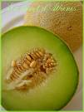
Melon
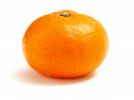
Orange
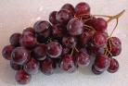
Grapes
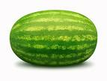
Watermelon
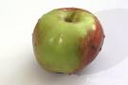
Apple
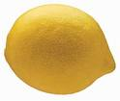
Lemon
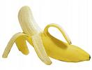
Banana
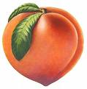
Peach
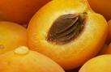
Apricot
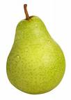
Pear
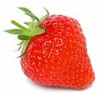
Strawberry
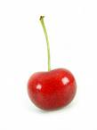
Cherry
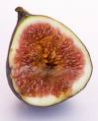
Fig
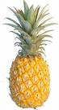
Pineapple
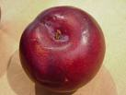
Plum
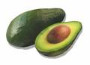
Avocado
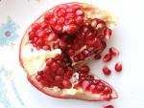
Pomegranate
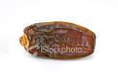
Date
*************************************

Part Two
2/ Vegetables
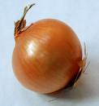
Onion
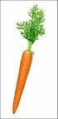
Carrot
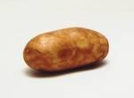
Potato
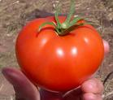
Tomato
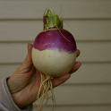
Turnip
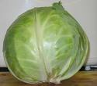
Cabbage
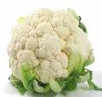
Cauliflower
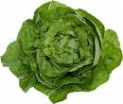
Lettuce

Peas
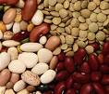
Beans
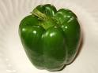
Pepper
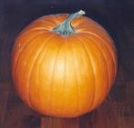
Pumpkin
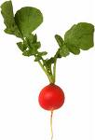
Radish
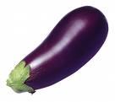
Eggplant / Aubergine
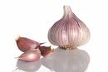
Garlic
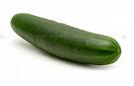
Cucumber
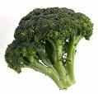
Brocoli

Mushroom
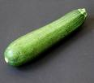
Zucchini / Courgette
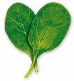
Spinach
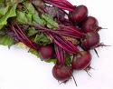
Beet / Beetroot
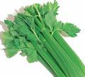
Celery
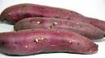
Sweet potato / Yam
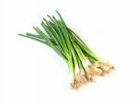
Green onion
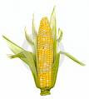
Corn
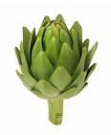
Artichoke
********************************************
Part Three
3/ Drinks
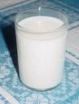
Milk
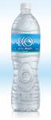
Water

Coffee
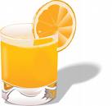
Orange Juice

Tea
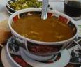
Soup

Lemonade / Soft drink
************************************
:
Part Five
5/ Other Types of Food
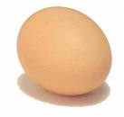
Egg
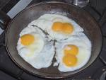
Fried eggs
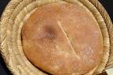
Bread
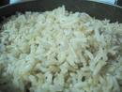
Rice
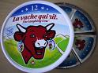
Cheese
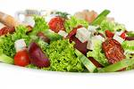
Salad

Hotdog
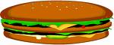
Sandwish

Candies / Sweets
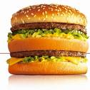
Big mac
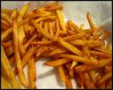
French fries

Pizza
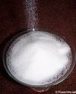
Sugar
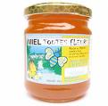
Honey
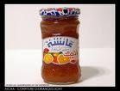
Jam
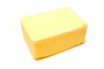
Butter
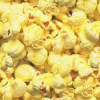
Popcorn
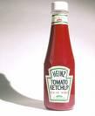
Ketchup
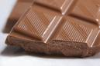
chocolate
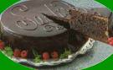
Cake

Ice cream
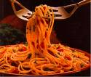
Spaghetti / Noodles
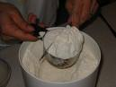
Flour
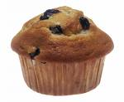
Muffin
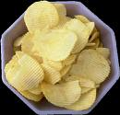
********************************************
:
Last Part
6 / Spices
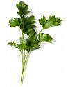
Parsley
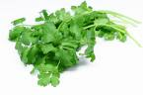
Coriander
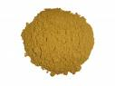
Cumin
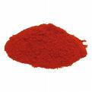
Paprika
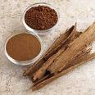
Cinnamon Powder
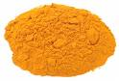
Turmeric
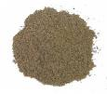
Black pepper
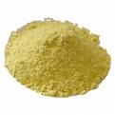
Ginger

Saffron
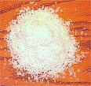
Salt
******************************

الدرس الثامن
Eighth Lesson
Countable and Uncountable Nouns
1-Countable Nouns
Countable nouns are easy to recognize. They are things that we can count. For example: "pen".
We can have one, two, three or more pens. Here are some more countable nouns:
• dog, cat, animal, man, person
• bottle, box, litre
• coin, note, dollar
• cup, plate, fork
• table, chair, suitcase, bag
Countable nounscan be singular or plural:
• My dog is playing.
• My dogs are hungry.
We can use the indefinite article a/an with countable nouns:
• A dog is an animal.
We can use some and any with countable nouns:
• I've got some dollars.
• Have you got any pens?
We can use a few/ few and many with countable nouns:
• I've got a few dollars.
• I haven't got many pens.
************************************************** ***********
2-Uncountable Nouns
Uncountable nouns are substances, concepts etc that we cannot divide into separate elements. We cannot "count" them.
For example, we cannot count "milk".
. Here are some more examples of uncountable nouns:
• music, art, love, happiness
• advice, information, news
• furniture, luggage
• rice, sugar, butter, water
• electricity, gas, power
• money, currency
We usually treat uncountable nouns as singular. We use a singular verb. For example:
• This news is very important.
• This coffee tastes bad.
We do not use the indefinite article a/an with uncountable nouns. We cannot say "an information" or "a music".
But we can say :
• a piece of news
• a bottle of water
• a grain of rice
We can use some and any with uncountable nouns:
• I've got some money.
• Have you got any rice?
We can use a little and much with uncountable nouns:
• I've got a little money.
• I haven't got much rice.
********************************************
Exercises:
• A/ Write "c" if the noun is countable, "uc" if the noun is uncountable.
Example: tomato:"c"
1. tree
2. sugar
3. rice
4. water
5. cup
6. friend
7. school
8. love
9. table
10. time
********************************************
B/• Use a singular or plural verb in the following exercises.
Remember uncountable nouns always take singular nouns.
Example: I like cheese. (like)
1. She (read)………….books every day.
2. They (come )……………..to school by minibus .
3. Karim (work)…………….very hard at home.
4. I (like)……………….to sit at the seaside in Alanya.
5. We always (do) …………..the exercises very carefully.
6. Mounir never (cook) ……………meals to us at home.
7. Some students (drive) ……………..very fast at the school campus.
8. He (speak)……………..two ********s ; English and French .
9. We (watch) …………..good films on tv every day
10. The class (begin)……………at 8:15
11. Milk...................healthy. (be)
12. Grape juice..................good. (taste)
13. Grapes.................delicious. (be)
14. A grape..................on the floor. (be)
15. Rome...............(be) a beautiful city.
16. Monkeys ....................bananas. (eat)
17. Sandwiches.......................... good. (be)
18. You........................ great pizza. (make)
19. The pictures ................beautiful. (look)
20. English...................... interesting. (be)
*****************************************
GOOD LUCK.

************************************************************

Food and Drink
Countable VS Uncountable nouns
Countable
Examples
A carrot /carrots
An apricot /apricots
An orange / oranges
A cake /cakes
An avocado / avocados
A banana / banana
A cucumber / cucumbers
A potato / potatoes
A turnip / turnips
A courgette / courgettes
****************************************
Uncountable
Examples
Milk
Coffee
Sugar
Water
Lemonade
Juice
Cheese
Bread
Meat
Tea
Butter
Jam
Honey
Beef
Oil

****************************************************

الدرس التاسع
There is / There are
There is a / an / + singular countable nouns
There is some + uncountable nouns.
There are + plural countable nouns.
Examples
There is a banana on the table.
There is some water in the fridge
There is some coffee in the kitchen
There is an apple in the basket
There is some tea in the teapot.
There is an orange in the plate.
There are some grapes in the fridge.
There are some carrots in the kitchen.
There are some eggs on the table.
- There are some potatoes in the basket.
Is there a / an / any
Are there any
Is there an apple in the kitchen
Yes, there is
No , there isn’t.
Is there a banana on the table
Yes, there is
Is there any water in the bottle
No, there isn’t.
Is there any tea in the teapot
Yes, there is / yes, there is some.
Are there any grapes on the table
Yes, there are.
Are there any onions in the basket
No ,there aren’t.
*********************************************

الدرس العاشر
Food and Drink
Eating Habits
Sample Paragraph
I eat bread with olive oil or jam and I drink some powdered milk or tea with mint for breakfast. For lunch, I eat cucumber salad and beef tajine and I drink a cup of banana juice. I eat fried eggs or a bowl of rice and I drink a milkshake for dinner
I like fresh fish and green tea very much. I dislike sausages and black coffee
************************************************
Some useful expressions
I’m hungry
I’m thirsty
Let’s go and have some drink
Can you recommend a good restaurant
What would you like to eat / drink
Would you like some orange juice
What about some cakes
May I have the menu, please
I’d like the bill, please
Keep the change
That’s not what I ordered
May I change this
What kind of seafood do you have
What kind of meat do you have
What kind of poultry dishes do you serve
Can I get you a drink
Are you hungry/thirsty
Boiled
Grilled
Toasted
***************************************
Containers + uncountable nouns
We can add some words to make uncountable nouns countable. These words are called containers
For example we can say
A jar of jam
A can of coke.
A slice of cheese.
A bottle / a glass of water.
A loaf of bread.
A bar of chocolate.
A carton of milk.
A bag of flour.
A box of cereal
A bowl of sugar.
A pack of gum
A tub of margarine
A tube of ketchup.
A cup of coffee.
A pocket of butter.
etc
**************************

الدرس الحادي عشر
Expressing permission
Can I go out
Yes, you can.
2/ Can I watch TV
No, you can’t
3/ Can I go to the cinema
No, you can’t.
4/ Can I sit near Rachid
Yes,you can.
5/ Can I change my place
Yes, you can.
6/ Can I drink some water
Yes, you can.
7/ Can I eat some buiscuits?
No, you can’t.
8/ Can I listen to music?
No, you can’t.
9/ Can I use your pen
Yes, you can.
10/ Can I play football
Yes, you can.
Things I can do in the classroom
I can read – I can speak – I can exchange ideas ...etc - .
Things I can’t do in the classroom
I can’t sleep – I can’t listen to radio – I can’t eat or drink – I can’t play football -...etc
Rule
Asking for permission
Can + Subject + verb
Accepting
Yes, you / he / she / they can
Refusing
No, you / he / she / they can’t
***********************************************

الدرس الثاني عشر
Expressing Time
Some useful expressions

What’s the time
What time is it
Excuse me. What time is it please
Excuse me. Do you have the time please
Excuse me. Could you tell me the time please
Can you tell me the time, please
Can you tell me what time it is
Excuse me. Do you happen to know what time it is
Do you have the time
Would you happen to know what time it is
******************************
Examples
04 : 00
It’s four o’clock
04 : 05
It’s five past four
04 : 08
It’s eight past four
04 : 10
It’s ten past four
04 : 12
It’s twelve past four
04 : 15
It’s a quarter past four
04 : 22
It’s twenty-two past four
04 : 25
It’s twenty-five past four.
04 : 30
It’s half past four
04 : 35
It’s twenty-five to five
04 : 40
It’s twenty to five
04 : 45
It’s a quarter to five
04 : 50
It’s ten to five
04 : 55
It’s five to to five
05 : 00
It’s five o’clock
It’s midday : 12 pm
It’s noon : 12 pm
It’s midnight : 12 am
Pm : afternoon
Am :: morning
************************************************** **********************************
Daily Activities
1/ what time do you get up?
I get up at seven o’clock
2/ what time do you have breakfast?
I have breakfast at half past seven.
3/ what time does Samir go to school?
He goes to school at a quarter to eight.
4/ what time does she come back home?
She comes back home at midday.
5/ What time do your parents have lunch?
They have lunch at two o’clock.
6/ What time do you go to bed?
I go to bed at half past nine.

***********************************************

الدرس الثالث عشر
Ordinal numbers

1
1st
first
2

2nd
second
3

3rd
third
4

4th
fourth
5

5th
fifth
6

6th
sixth
7

7th
seventh
8

8th
eighth
9

9th
ninth
10

10th
tenth
11

11th
eleventh
12
12th
twelfth
13

13th
thirteenth
14

14th
fourteenth
15

15th
fifteenth
16

16th
sixteenth
17

17th
seventeenth
18

18th
eighteenth
19

19th
nineteenth
20

20th
twentieth
21

21st
twenty-first
30

30th
thirtieth
40

40th
fortieth
50

50th
fiftieth
60

60th
sixtieth
70

70th
seventieth
80

80th
eightieth
90

90th
ninetieth
100

100th
one hundredth
1,000

1000th
one thousandth
***************************
What’s the date today?
Wed, Feb.6th = Today is Wednesday, February the ninth.
Sun, Aug.1st = Today is Sunday, August the first.
Sat, Sept.3rd = Today is Saturday, September the third.
Mon, Dec. 22nd = Today is Monday, December the twenty-second.
Tue, May.21st = Today is Tuesday, May the twenty-first.
Thur, Jan. 20th = Today is Thursday, January the twentieth.
Fri, Jul 31st = Today is Friday, July the thirty-first
***************************************

Sample Writing
This is my dream house. It’s in Tangier. There are three large bedrooms, two nice living rooms, a lovely dining room, a modern kitchen, a new bathroom and beautiful garden.
I like my dream house very much because there is a wonderful swimming pool and a wide courtyard.
**********************************
Remark: draw your dream house

*********************************************

Prepositions
In / on / under / next to / between
*********************
Dialogue
Ahmed : Where’s my notebook
Jamal : It’s on your bed.
Ahmed : No, it isn’t.
Jamal : Well, is it under your bed
Ahmed : No.
Jamal : Maybe it’s in the closet.
Ahmed : No, it isn’t in the closet.
Jamal : Is it between the table and the bed
Ahmed : Well, I don’t know. Maybe it’s next to your stereo.
Jamal : Oh, that’s right
*********************
The book is on the table
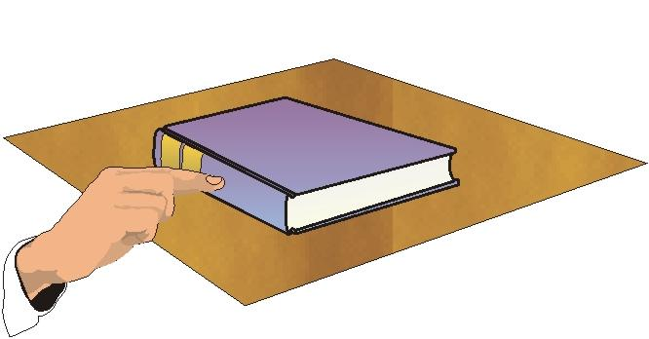
The cat is under the table
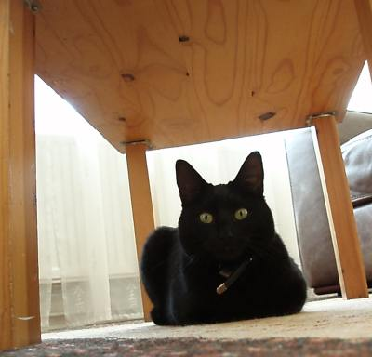
The colour pencils are in the pencil case
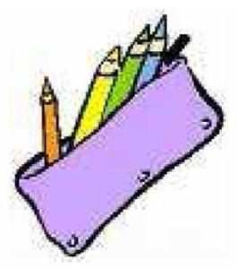
The blue pen is between the red and yellow pens
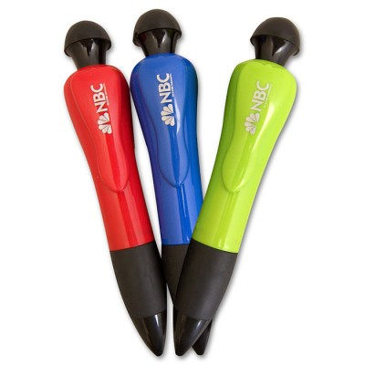
The lamp is next to bed

*************************************************

الدرس الرابع عشر
Vocabulary: Parts of a house
1/ Bedroom
Bed
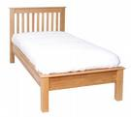
Bedside table
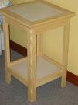
Bedside lamp
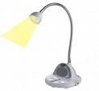
Wardrobe / closet
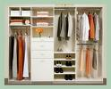
Matress
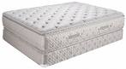
Pillow

Blanket
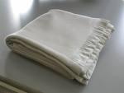
chest of drawers
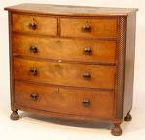
Bedspread
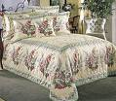
Alarm clock
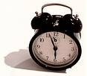
Window
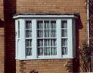
2/ Bathroom
shower
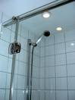
Bath
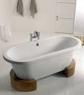
Bidet
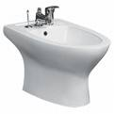
Washbasin
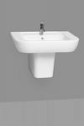
Tap
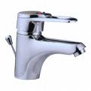
Mirror
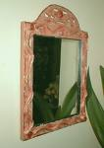
Sponge bag
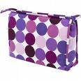
Soap
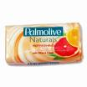
Soap dish
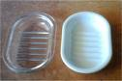
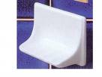
Towel
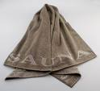
Towel rail
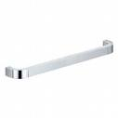
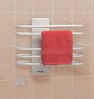
Bath mat
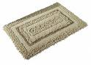
Toilet paper

Toilet
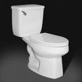
Comb
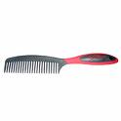
Hair brush
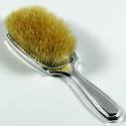
Hair drier
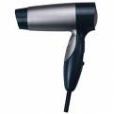
Shampoo
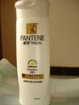
Conditioner
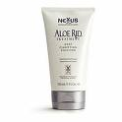
Safety razor / shaver
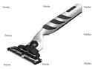
Electric razor / electric shaver
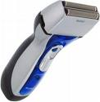
Shaving foam

Toothpaste

Toothbrush

Nail brush
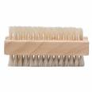
*******************************************************

Kitchen
Fridge / Freezer / Refrigerator
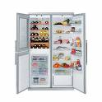
Oven
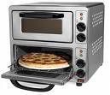
Microwave oven
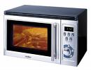
Stove / Cooker
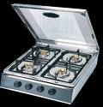
Washing machine
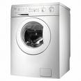
Toaster
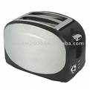
Kettle
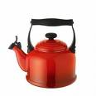
Teapot
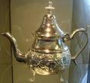
Coffee pot
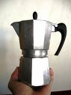
Liquidizer / Blender
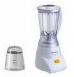
Mixer
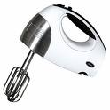
Broom
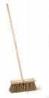
Sink

Waste bin

Worktop

Tea towel
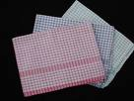
Saucepan
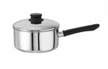
Frying pan
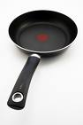
Pressure cooker
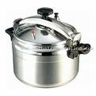
cup and saucer
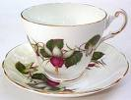
spoon
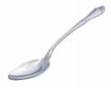
Fork
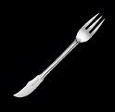
Tin opener
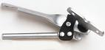
Knife
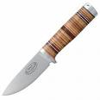
Teaspoon
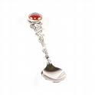
Cutlery drawer
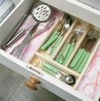
Glass

Jug
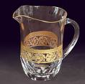
Living room/ Sitting room
table
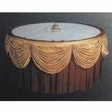
chair
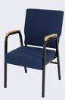
Armchair
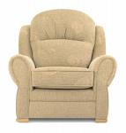
Sofa

Rug
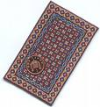
Carpet
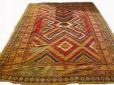
Fireplace
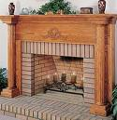
Radiator
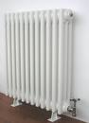
Television
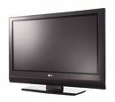

******************************************************

Types of houses
A block of flats
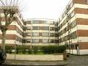
A house
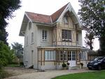
A barn
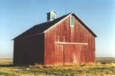
A hut
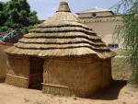
A tent
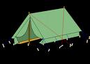
A villa
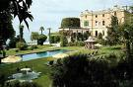
A bungalow

A cottage
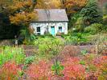
A tree house
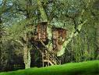
A teepee
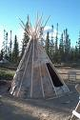
An igloo
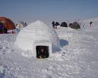
A palace
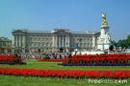
A temple
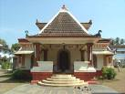
A castle

A skyscraper


*****************************************************

الدرس الخامس عشر
Have got / has got
1/ Have you got black socks ?
No, I haven’t.
2/ Has Samir got blue eyes?
Yes, he has.
3/ Has Karima got a white skirt?
No, she hasn’t.
4/ Have they got green eyes?
No, they haven’t.
5/ Has your cat got small ears?
Yes, it has.
6/ Have you got got long feet?
No, I haven’t.
7/ Has Rachid got white pants?
Yes, he has.
8/ Has Mounir got a beard?
No, he hasn’t.
9/ Has your sister got a long hair?
Yes, she has.
10/ Have you got a brown jacket?
Yes, I have.
************************************************** ************************************************** ************************
- I have got a blue shirt and a pair of green jeans.
- I haven’t got blue eyes.
- He has got a curly hair.
- He hasn’t got a black jacket.
- She has got a red dress.
- She hasn’t got black shoes
- We have got green trousers.
- We haven’t got small noses.
************************************************** ************************************************** ************************
Rule
Affirmative sentences
I / you / we / they + have got ……….
He / she / it + has got………..
Negative sentences
I / you / we / they + haven’t got (have not got)……….
He / she / it + hasn’t got ( has not got)………..
Yes / no questions
Have + I /you / we / they + got………?
Has + he / she / it + got……………....?
************************************************** ************************************************** ************************************************** ************************
Singular
Affirmative
I have got a pen = I've got a pen
You have got a pen = You've got a pen
She has got a pen = She's got a pen
He has got a pen = He's got a pen
It has got a pen = It's got a pen
Negative
I have not got a pen = I haven't got a pen
You have not got a pen = You haven't got a pen
She has not got a pen = She hasn't got a pen
He has not got a pen = He hasn't got a pen
It has not got a pen = It hasn't got a pen
Questions
Have I got a pen?
Have you got a pen?
Has he got a pen?
Has she got a pen?
Has it got a pen?
Plural
Affirmative
We have got a pen = We've got a pen
You have got a pen = You've got a pen
They have got a pen = They've got a pen
Negative
We have not got a pen = We haven't got a pen
You have not got a pen = You haven't got a pen
They have not got a pen = They haven't got a pen
Questions
Have we got a pen?
Have you got a pen?
Have they got a pen?
****************************************
One / ones
-Hisham has got blue pants but he hasn’t got green ones.
-Layla hasn’t got white skirt but she’s got a blue one.
-I have got a black tie. I haven’t got a red one.
-Samir has got a brown jacket. He hasn’t got a black one.
-Amine hasn’t got white trainers. He has got grey ones
************************************************** *****

الدرس السادس عشر
Present Continuous
the present continous describes things that are happening now, at the moment or future plans and arrangements
Common present continuous time expressions include
at the moment, now, today, this week, this month, tomorrow, next week (for future arrangements ), currently
Rule
verb to be ( in simple present) + verb + ing
Examples
Affirmative
- I am speaking.
- You are speaking.
- We are speaking.
- They are speaking.
- He is speaking.
- She is speaking.
- It is speaking.
Negative
- I am not speaking.
- You are not speaking.
- We are not speaking.
- They are not speaking.
- He is not speaking.
- She is not speaking.
- It is not speaking.
Question
- Am I speaking
- Are you speaking
- Are we speaking
- Are they speaking
- Is he speaking
- Is she speaking
- Is it speaking
Short and full Forms
Affirmative
I'm (I am) -> working today.
You're (You are) -> working today.
He's (He is) -> working today.
She's (She is) -> working today.
It's (It is) -> working today.
We're (We are) -> working today.
You're (You are) -> working today.
They're (They are) -> working today
Negative
I'm not (I am not) -> coming this evening.
You aren't (You are not) -> coming this evening.
He isn't (He is not) -> coming this evening.
She isn't (She is not) -> coming this evening.
It isn't (It is not) -> coming this evening.
We aren't (We are not) -> coming this evening.
You aren't (You are not) -> coming this evening.
They aren't (They are not) -> coming this evening
*******************************************
الدرس السابع عشر

The present continuous
Yes / no questions
Examples
Are you reading a story
Yes, I am
Is Hamid listening to the radio
No, he isn’t
Is he writing a letter
Yes, he is
Is Loubna studying
Yes, she is
Is your cat sleeping
No, it isn’t
Are Kamal and Najib travelling to Marrakesh
No, they aren’t
Are they playing soccer
Yes, they are
w/h questions
What are you doing
I am painting my room
What is Houda doing
She is knitting
When are you travelling
I’m travelling this evening
Where are they going to this weekend
They are going to the stadium
Remember
A single, silent e at the end of the word is dropped before ing
example: come - coming
I am coming home. You are coming home. He is coming home
.
But: ee at the end of the word is not changed
example: agree - agreeing
The final consonant after a short, stressed vowel is doubled before ing.
example: sit - sitting
I am sitting on the sofa. You are sitting on the sofa. He is sitting on the sofa
The letter l as final consonant after a vowel is always doubled before ing
example: travel - travelling
I am travelling around. You are travelling around. He is travelling around
Important: This applies only for British English; in American English there is usually only one l
An ie at the end of a word becomes y before ing
example: lie - lying
I am lying in bed. You are lying in bed. He is lying in bed
Afirmative / negative forms
Full / short forms
Examples
I am playing. - I'm playing.
I am not playing. - I'm not playing.
He is playing. - He's playing.
He is notplaying. - He's not playing. / He isn't playing.
We are playing. - We're playing.
We are not playing. - We're not playing. /We aren't playing
الدرس الثامن عشر
Making suggestions
Some expressions
- Let’s revise our lessons.
- What about going to the cinema tonight
- How about playing cards
- Why don't we do our homework
- Couldn't we invite your grandmother to our party
- Shall we have a walk along the river
- What would you say to a cup of coffee
- Don't you think it is a good idea to watch TV
- Does it matter if we use your car
Accepting a suggestion
- Ok. Yes, let's.
- Yes, I'd like to
- Yes, I'd love to.
- What a good idea
- Why not
- Yes, with pleasure.
- Yes, I feel like taking a walk.
Disagreeing with a suggestion
- No, let's not.
- No, I'd rather not.
- I don't feel like it.
- I dislike doing homework.
- What an awful idea
Examples
.Let’s go to the zoo
No, I don’t like animals.
How about going to the park
Yes that’s a good idea. Let’s go
. I think you should buy the blue one.
That's a good idea.
. I don't think you should sell your car.
Thanks for the advice, but I really need the money.
. Let's go bowling tonight.
Sorry, I can't. I'm meeting a friend for dinner.
Why don't we go skiing on Saturday
Sounds like a good idea. Where do you want to go
. Why don't you come with me to Fez
Thanks, but I've already been there.
Expressing ability
Rule: can + subject + verb
Examples
Can you play rugby
No, I can’t, but I can play football
Can you climb a mountain
Yes, I can
Can you drive a car
No , I can’t
Can they play water polo
No, they can't
Can he play ice hockey
Yes, he can

الدرس التاسع عشر

Adverbs of frequency
The most common adverbs of frequency are
always, usually, often, sometimes, seldom, rarely, and never
The basic rule is that adverbs of frequency come before the main verb
but they come after present and past forms of the verb be: am, are, is, was and were
Examples
I always go to school by bus
He often drinks some milk in the morning.
She seldom drive to work
They sometimes watch TV in the morning.
He is always on time
It is sometimes cold in the south
You are never satisfied
100% = Always
75 % = Usually
50% = Often
25% = Sometimes
5% = Seldom / Rarely
0% = Never

الدرس العشرون

What’s the weather like
It’s sunny
It’s cloudy
It’s rainy
It’s windy
It’s snowy
It’s fine
It’s hot
It’s a beautiful day
......................
Song
"What's the weather like?"
by Richard Graham
What's the weather like?
What's the weather like?
What's the weather like today?
What's the weather like?
What's the weather like?
What's the weather like today?
It's rainy
It's cloudy
It's windy
And it's snowy.
( Repeat Chorus)
It's sunny
It's fine
It's hot
It's a beautiful day!
( Repeat Chorus
sample dialogues
What's the weather like in Tafraout
It's sunny
And what's the temperature
It's very hot. It's 39 degrees Celsius
What's the weather like in Alaska
it's snowy
And what's the temperature there
it's very cold. it's -20 ° Celsius
three useful links about weather lesson
link 1
link 2
link3
Parts of Speech
Nouns
Camel – house – train – car – Jamal – Naima – school – machine – song – sport – pencil – bag – cabbage – onion – cup – etc
Verbs
Come – sing – write – read – have – be – walk – swim – hit – begin – cook – speak – like – play – eat – drink - watch – smile – dream – sleep – travel – tie – clean – stay –get – see – start – work – want – etc
Acjectives

Tall – long – beautiful – ugly – short – nice – slim – fat – big – wonderful – exciting – new – old – narrow – wide – small – interesting – boring – funny – colourful – important – sunny – cloudy – snowy – windy – hot – cold – warm – etc
Adverbs

Well – slowly – very – quite – always – usually often – seldom - quickly – rarely – sometimes – early – now – never – finally – badly – soon – today – tomorrow – etc
Pronouns

I – you – he – she – it – we – they – me – him – her – us – them – mine – our – etc
Prepositions
In – on – under – over – between – next to – in front of – off –of - by – with – without – behind – above –beside – below – out of – through –towards – into – along – around/ round – down – about
Months and Seasons of the Year
Months
- January
- February
- March
- April
- May
- June
- July
- August
- September
- October
- November
- December
The Seasons
Spring:
March
April
May
Summer:
June
July
August
Autumn:
September
October
November
Winter:
December
January
February
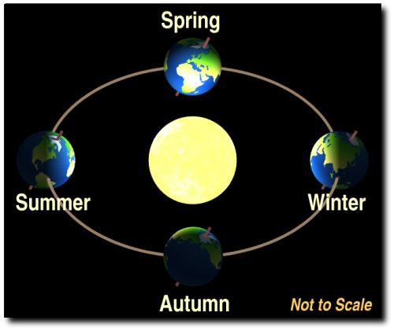

**************************************************************

الدرس الحادي والعشرون
Simple Past of the Verb Be
Affirmative form
I was
You were
He was
She was
It was
We were
You were
They were
Negative form
short forms:
I wasn’t
You weren’t
He wasn’t
She wasn’t
It wasn’t
We weren’t
You weren’t
They weren’t
long forms:
I was not
You were not
He was not
She was not
It was not
We were not
You were not
They were not
Interrogative form
Was I ?
Were you ?
Was he ?
Was she ?
Was it ?
Were we ?
Were you ?
Were they ?
Yes/ no questions
Were you absent yesterday ?
Yes, I was.
Was Rachid at home last Monday ?
No, he wasn’t.
Were they in Marrakesh two days ago ?
No, they weren’t
Simple past of regular verbs
The simple past of regular verbs is usually formed by adding -ED to the verb
However, with some verbs, you need to add -ED or change the ending a little
Here are the rules
Verbs ending in e = we add d
examples : live = lived
date = dated
type = typed
Verbs ending in consonant + y = we change y to i, then we add ed
examples : try = tried
cry = cried
spy = spied
Verbs ending in one vowel + one consonant ( but NOT w or y ) = we double the consonant, then we add ed
. examples: commit = committed
tap = tapped
fit = fitted
For the rest of regular verbs we just add ed
examples : play = played
work = worked
look = looked
*******************************************************

Simple Past: Irregular Verbs

Introduction
Although many verbs in English form their past tense with -ED, some do not. These are called irregular verbs, and they include some of the most basic verbs in English. This page will explain some of the most important patterns in forming the past tense. However, the only way to know how an irregular verb will change in the past tense is to learn all of the important verbs.

1. The three most important irregular verbs
The three most important irregular verbs are BE, HAVE, and DO. The simple past forms for BE are different depending on the subject.
Pronoun | BE | HAVE | DO
I | was | had | did
You | were | had | did
He / she / it | was | had | did
We | were | had | did
They | were | had | did

2. Other irregular verbs
Other irregular verbs fall into three main categories:
Category | Examples
Verbs which don't change | cut - cut  hit - hit  fit - fit
Verbs which change their vowel | get - got  sit - sat  drink - drank
Verbs which change completely | catch - caught  bring - brought  teach - taught
When you are sure that you understand the lesson, you can continue with the exercises.
Irregular Verbs
Base Form | Simple Past Tense | Past Participle
awake | awoke | awoken
be | was, were | been
bear | bore | born
beat | beat | beat
become | became | become
begin | began | begun
bend | bent | bent
beset | beset | beset
bet | bet | bet
bid | bid/bade | bid/bidden
bind | bound | bound
bite | bit | bitten
bleed | bled | bled
blow | blew | blown
break | broke | broken
breed | bred | bred
bring | brought | brought
broadcast | broadcast | broadcast
build | built | built
burn | burned/burnt | burned/burnt
burst | burst | burst
buy | bought | bought
cast | cast | cast
catch | caught | caught
choose | chose | chosen
cling | clung | clung
come | came | come
cost | cost | cost
creep | crept | crept
cut | cut | cut
deal | dealt | dealt
dig | dug | dug
dive | dived/dove | dived
do | did | done
draw | drew | drawn
dream | dreamed/dreamt | dreamed/dreamt
drive | drove | driven
drink | drank | drunk
eat | ate | eaten
fall | fell | fallen
feed | fed | fed
feel | felt | felt
fight | fought | fought
find | found | found
fit | fit | fit
flee | fled | fled
fling | flung | flung
fly | flew | flown
forbid | forbade | forbidden
forget | forgot | forgotten
forego (forgo) | forewent | foregone
forgive | forgave | forgiven
forsake | forsook | forsaken
freeze | froze | frozen
get | got | gotten
give | gave | given
go | went | gone
grind | ground | ground
grow | grew | grown
hang | hung | hung
hear | heard | heard
hide | hid | hidden
hit | hit | hit
hold | held | held
hurt | hurt | hurt
keep | kept | kept
kneel | knelt | knelt
knit | knit | knit
know | knew | know
lay | laid | laid
lead | led | led
leap | leaped/leapt | leaped/leapt
learn | learned/learnt | learned/learnt
leave | left | left
lend | lent | lent
let | let | let
lie | lay | lain
light | lighted/lit | lighted
lose | lost | lost
make | made | made
mean | meant | meant
meet | met | met
misspell | misspelled/misspelt | misspelled/misspelt
mistake | mistook | mistaken
mow | mowed | mowed/mown
overcome | overcame | overcome
overdo | overdid | overdone
overtake | overtook | overtaken
overthrow | overthrew | overthrown
pay | paid | paid
plead | pled | pled
prove | proved | proved/proven
put | put | put
quit | quit | quit
read | read | read
rid | rid | rid
ride | rode | ridden
ring | rang | rung
rise | rose | risen
run | ran | run
saw | sawed | sawed/sawn
say | said | said
see | saw | seen
seek | sought | sought
sell | sold | sold
send | sent | sent
set | set | set
sew | sewed | sewed/sewn
shake | shook | shaken
shave | shaved | shaved/shaven
shear | shore | shorn
shed | shed | shed
shine | shone | shone
shoe | shoed | shoed/shod
shoot | shot | shot
show | showed | showed/shown
shrink | shrank | shrunk
shut | shut | shut
sing | sang | sung
sink | sank | sunk
sit | sat | sat
sleep | slept | slept
slay | slew | slain
slide | slid | slid
sling | slung | slung
slit | slit | slit
smite | smote | smitten
sow | sowed | sowed/sown
speak | spoke | spoken
speed | sped | sped
spend | spent | spent
spill | spilled/spilt | spilled/spilt
spin | spun | spun
spit | spit/spat | spit
split | split | split
spread | spread | spread
spring | sprang/sprung | sprung
stand | stood | stood
steal | stole | stolen
stick | stuck | stuck
sting | stung | stung
stink | stank | stunk
stride | strod | stridden
strike | struck | struck
string | strung | strung
strive | strove | striven
swear | swore | sworn
sweep | swept | swept
swell | swelled | swelled/swollen
swim | swam | swum
swing | swung | swung
take | took | taken
teach | taught | taught
tear | tore | torn
tell | told | told
think | thought | thought
thrive | thrived/throve | thrived
throw | threw | thrown
thrust | thrust | thrust
tread | trod | trodden
understand | understood | understood
uphold | upheld | upheld
upset | upset | upset
wake | woke | woken
wear | wore | worn
weave | weaved/wove | weaved/woven
wed | wed | wed
weep | wept | wept
wind | wound | wound
win | won | won
withhold | withheld | withheld
withstand | withstood | withstood
wring | wrung | wrung
write | wrote | written

الدرس الثاني والعشرون

Simple Past: Irregular Verbs
Although many verbs in English form their past tense with -ED, some do not. These are called irregular verbs, and they include some of the most basic verbs in English
However, the only way to know how an irregular verb will change in the past tense is to learn all of the important verbs

1/ The three most important irregular verbs
The three most important irregular verbs are BE, HAVE, and DO

simple past of verb be (see lesson21 above

simple past of verb have

I had
you had
He had
She had
It had
We had
You had
They had

Simple past of verb do

I did
you did
He did
She did
It did
We did
You did
They did

2/ Other Irregular Verbs

A/ Verbs which don't change: for example

Put -cut - fit - hit -bet -bid-cast-cost-let ..etc

Example
Yesterday, he cut his finger with a kinfe

The car hit the tree two days ago

B/ verbs which change their vowels

get : simple present = got : simple past
sit = sat
drink = drank
awake = awoke
come = came
drive = drove
know = knew

etc

examples

She drank a cup of cold milk last Monday

They came home late yesterday

C/ Verbs which change completely
Example

Catch : simple present = caught : simple past
Teach = taught
Eat = ate
Fight = fought
Find = found
Go = went
Keep = kept
See = saw

Etc

Example

I saw a bad film yesterday
She went to the dentist last Friday

List of irregular verbs + past participle + French translation

http://flyn.free.fr/

http://www.englishpage.com/irregularverbs/irregularverbs.html

